**The Link Between Public Health and Public Transportation: An Agent-Based Model(ABM) Analysis**

Supervisors: Prof. Giovanna Di Marzo Serugendo

& Flann Chambers

Reporters: Chloe Farat, Ying JIN

**Acknowledgements**

This work is under supervison of Prof. Giovanna Di Marzo Serugendo and Flann Chambers. We would like to thank them who provided invaluable feedback and insights that greatly enhanced the quality of this document.

**Introduction**

In modern cities, the interplay between public health and transportation is crucial. Urban populations rely heavily on public transportation systems for commuting, social activities, and accessing healthcare services. However, these densely populated and highly interconnected environments also facilitate the rapid spread of infectious diseases. Understanding how diseases propagate through urban populations and assessing the impact of various factors such as population density, mobility patterns, and healthcare infrastructure is essential for devising effective public health policies and interventions. To study this issue, a sophisticated ABM designed to investigate the intricate relationship between public health and public transportation systems within urban environments. By simulating the interactions between individuals, healthcare infrastructure, and transportation networks, the model aims to provide valuable insights into the dynamics of disease transmission and the effectiveness of interventions in mitigating its spread.

**User Case**

The model simulates the environment of the canton of Geneva and analyzes a group of individuals within the area, including both infected and healthy subjects. Individuals (people) move between their homes, hospitals, and social gatherings (friends' homes) using either walking or public transports (trams, trolleybuses and buses). Hospitals provide healthcare services to individuals, and Geneva Public Transport (French: Transports publics genevois, TPG) stops represent locations where people can access transport services.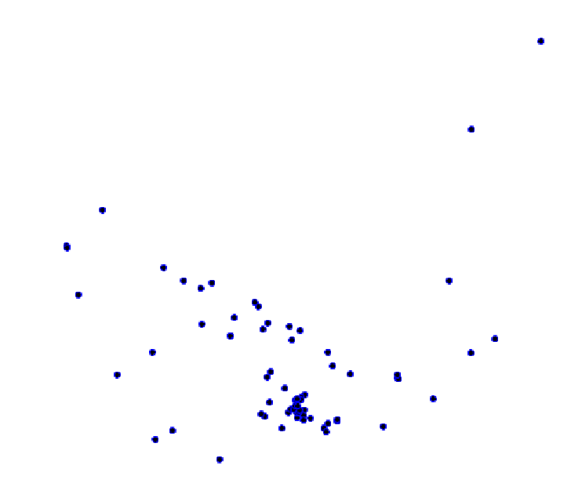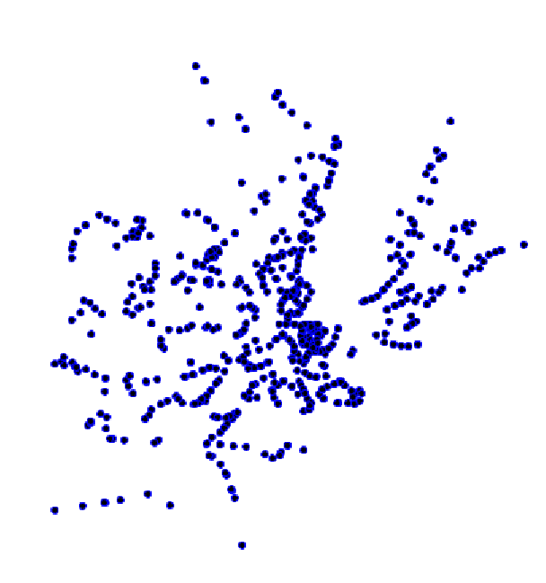

Figure 1: Distribution of healthcare centers(left) and TPG stops (right) within the canton of Geneva

Information associated with healthcare centers and the TPG stops across the canton were incorporated. The distribution of the data is demonstrated in Figure 1.

**DPSIR Framework**

The Driving forces in this scenario include population density, mobility patterns, and disease transmission dynamics:

* Driving Forces:

1. Population Density: Determines the likelihood of disease transmission.
2. Mobility Patterns: Influence the spread of diseases through interactions between individuals.

* Pressures:

1. Number of Infected Individuals: Directly correlates with the burden on healthcare systems and potential for further transmission.
2. Increased Transportation Usage: Augments the risk of disease dissemination through heightened human contact.
3. Rise in Healthcare Facility Visits: Amplifies strain on healthcare infrastructure and personnel.

* State:

1. Population Health Status: Reflects the overall resilience and vulnerability to disease outbreaks.
2. Availability and Distribution of Healthcare Services: Determines accessibility and effectiveness of medical interventions.

* Impacts:

1. Strain on Healthcare Facilities: Increased demand for healthcare services due to the increase of infected individuals.
2. Delayed Access to Healthcare: Lengthened wait times and decreased efficiency in receiving medical care.

* Responses:

1. Adjusting Hospital Capacities: Increasing hospital capacities to accommodate the influx of infected individuals.
2. Optimizing Transportation Services: Adapting public transportation services to minimize disease transmission.
3. Enforcing Mobility Restrictions (in severe circumstances): Imposing limitations on population movement to contain the spread of contagion.

**Agent-Based Model**

The model comprises three types of agents: People, Hospitals and TPG Stops

**People**:

* Each person is represented by the ‘people’ species with respective attributes and categories of ‘adult’ and ‘elder’ as shown in Figure 2.

Figure 2: Screenshot of GAMA code that defines 'people' agents with attributes and categories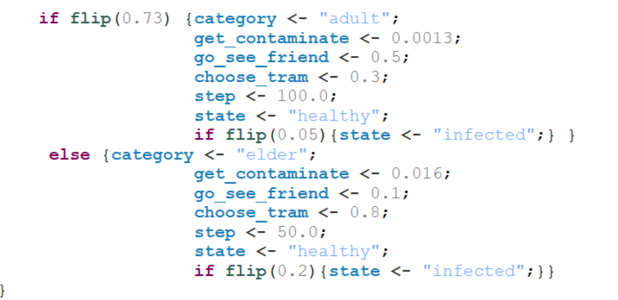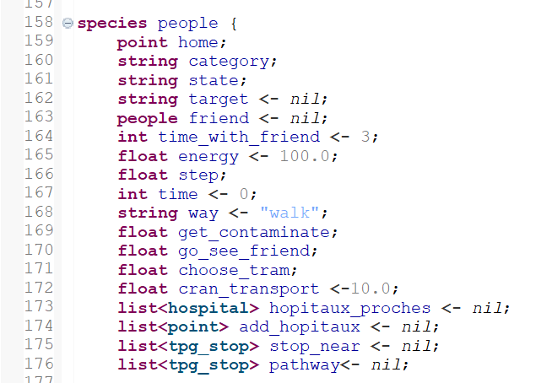

* People have reflexes to handle infection, change targets (e.g., hospital or friend's house), navigate to hospitals or friends' homes, and manage interactions with the environment.

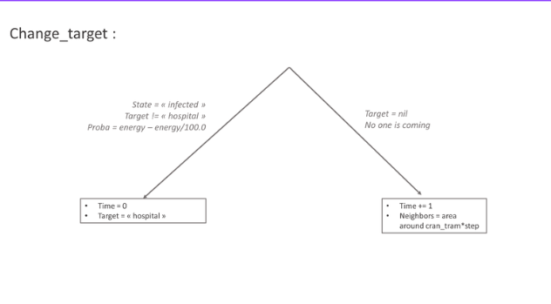

**Interactions**

* People-to-People Interactions:

Infection Spread:

* + Infected individuals can transmit the infection to nearby healthy individuals within a certain radius.
  + This interaction occurs through the ‘infection’ reflex in the ‘people’ species.
  + When an infected individual's ‘energy’ decreases due to illness, they die.
  + Healthy individuals may get infected based on the probability of infection (‘get_contaminate’).

Social Interactions:

* + Individuals may have social interactions by visiting friends' homes, with the probability ‘go_see_friend’.
  + This interaction occurs through the ‘go_meet_friend’ reflex in the ‘people’ species.
  + Individuals navigate to their friends' homes, spending time together before returning to their respective locations.

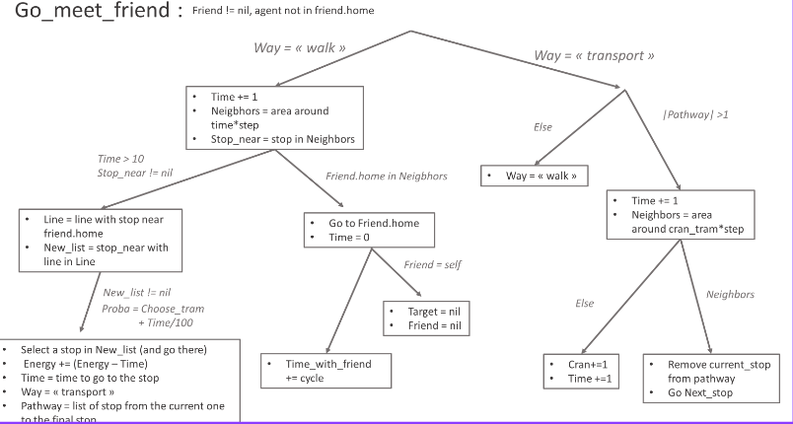

* People-Hospital Interactions:
  + Infected individuals seek medical care by transitioning to the "hospital" target state.
  + Hospitals treat patients, potentially curing them and transitioning them back to a healthy state.
  + Hospitals adjust their capacities based on infection rates, influencing the availability of healthcare resources.

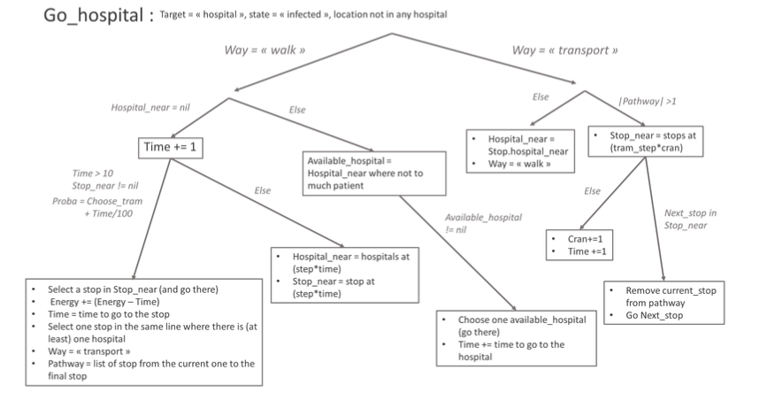

* People-TPG Stop Interactions:
  + Individuals decide whether to use public transport (tram) based on predefined probabilities.
  + Tram usage may increase for infected individuals due to illness, affecting their transport choices.
  + TPG stops near hospitals are identified and considered for potential adjustments in tram services.

**Hospitals**:

* Hospital agents represent healthcare centers dedicated to treating infected patients with various attributes as shown in Figure 3.

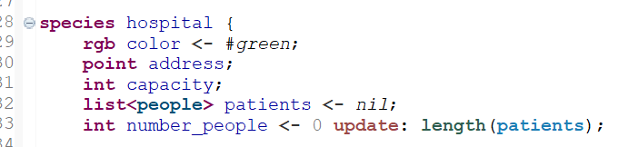

Figure 3: Screenshot of GAMA code that defines 'Hospitals' agents with attributes

* Hospitals have a reflex for treating patients, potentially leading to their recovery based on a probability of cure (‘proba_cure’).

**TPG Stops:**

* TPG stop agents represent public transport stops with various attributes as shown in Figure 4.

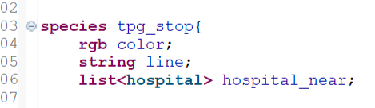

Figure 4: Screenshot of GAMA code that defines 'TPG Stops’' agents with attributes

* TPG stops are initialized based on geographic data and detect their proximity to hospitals.
* TPG Stop-Hospital Interactions:
  + TPG stops detect their proximity to hospitals, ensuring that tram services are available in areas with healthcare facilities.
  + Hospitals influence tram services by triggering the creation of additional tram stops in areas with high infection rates.

**Reaction of environment**

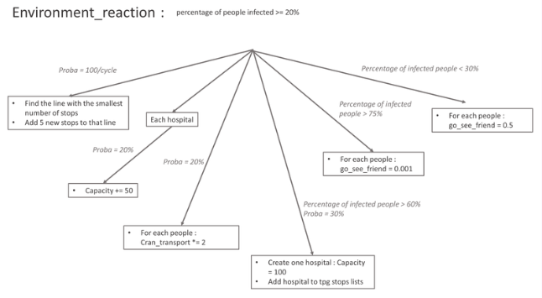

The model also simulates dynamic responses to varying infection rates, encompassing adjustments in healthcare capacity, public transportation, individual behavior, and social interactions based on the severity of the outbreak. It contains a segment that triggers a reactive response in the environment when the ratio of contaminated individuals to the total population exceeds or equals 0.2. Within this trigger, hospitals have a 20% chance of increasing their capacity by 50, while adjustments to public transportation occur with a 1% chance per cycle, including the creation of new tram stops near healthcare facilities. Additionally, individuals' transport behavior is modified, doubling their cranial transport attribute with a 20% chance if the infection ratio exceeds 0.2. New hospitals are established if the contamination ratio surpasses 60%, with a 30% chance, equipped with a capacity of 100 and associated with nearby public transportation stops and hospitals. Social behavior is also influenced, with individuals less likely to visit friends if the contamination ratio exceeds 75%, while they are more inclined to do so if the ratio drops below 30%.

**Results expected**

If the model performs as anticipated, more transport stops near hospitals as well as more healthcare centers should correlate with a lower rate of infection in the population and less time to go to hospital.

**Results of model**

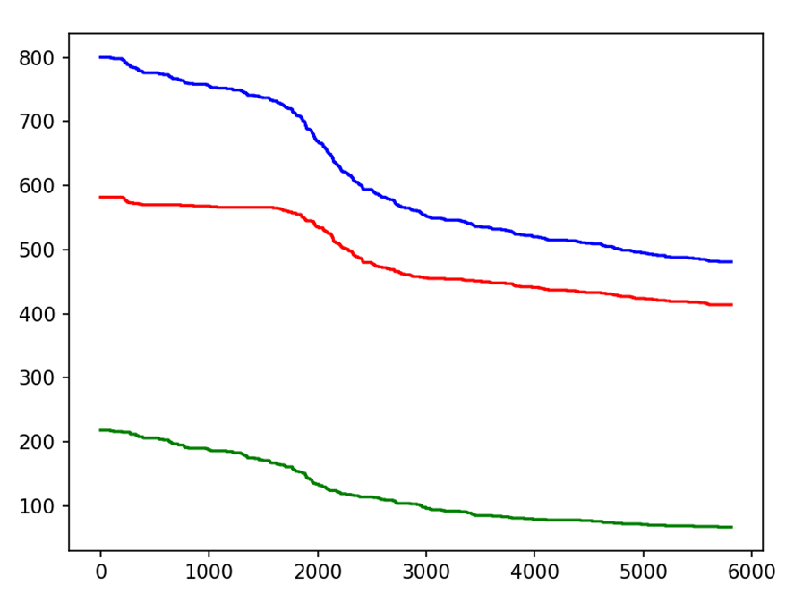

Evolution of the total population (blue), the number of elders (green) and the number of adults (red)

The first result we considered is the number of people during the experiment. Over the course of 1800 cycles, it gradually decreases. Following this period, the population sharply decreases until the 3000th cycle with around 20% of the population dying from the disease. This significant reduction can be attributed to a high rate of infection in earlier cycles. Subsequent results will further corroborate this interpretation. Ultimately, the population decline mirrored the gradual decrease observed at the onset of the simulation.

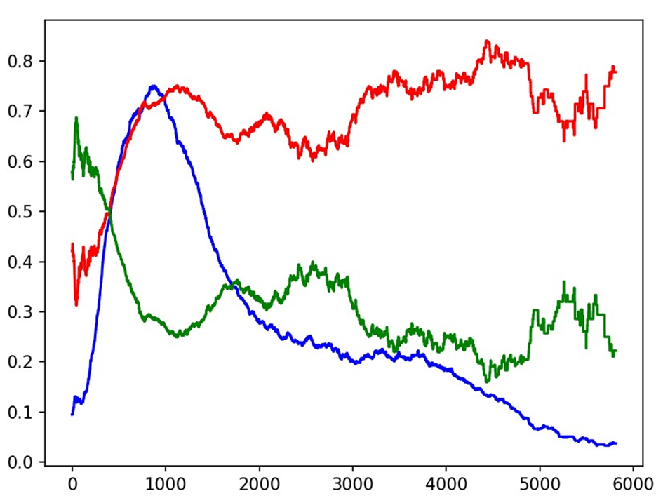

Percentage of the population who is infected (blue), portion of elders infected (green), portion of adults infected (red)

Observing the blue line on the graph, we notice that the percentage of infected individuals dramatically escalates at the onset of the simulation, reaching a peak of 77% around the 1000-cycle mark. Subsequently, the figures sharply drop until the 2000th cycle and then steadily decline until the simulation concludes. [add theories]

Regarding the trends illustrated by the green and red lines, the simulation outcomes deviate from anticipated results. Initially, the elderly demographic represents a larger fraction of the infected population compared to adults. However, this trend quickly reverses, with adults becoming the majority of cases for most of the simulation. [add theories]

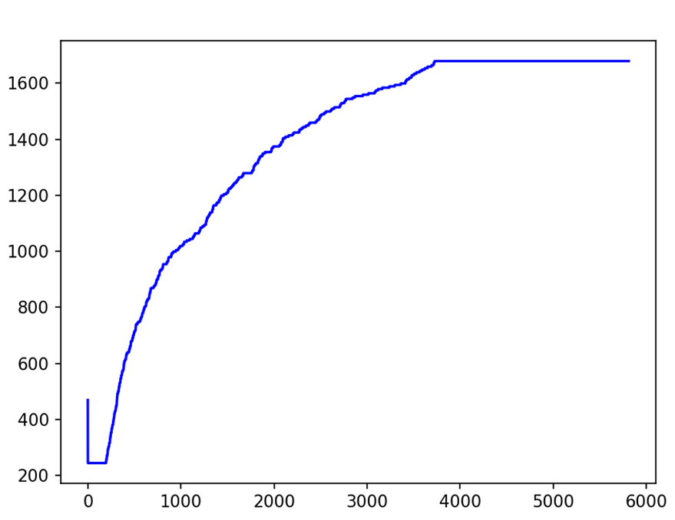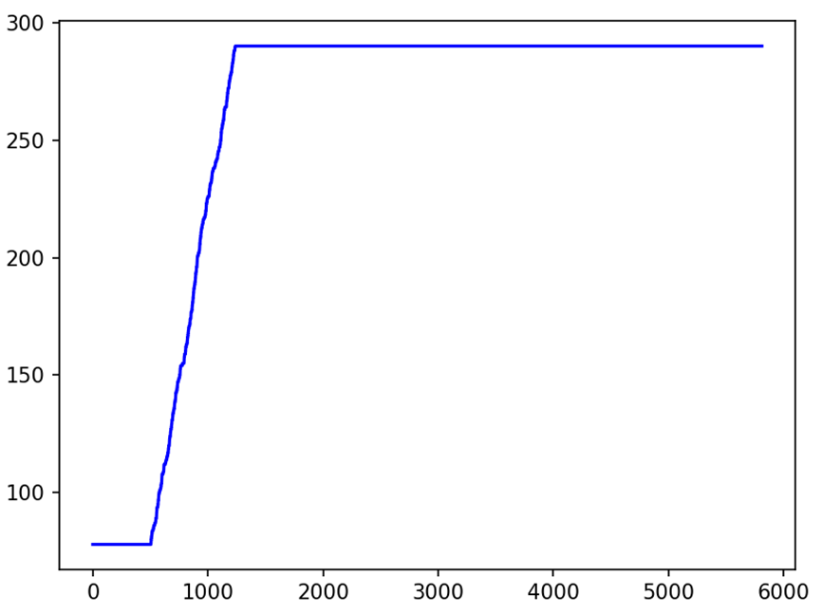

Evolution of number of hospitals and TPG stops

As depicted by the graph on the left, the number of hospitals remains constant for the first 500 cycles. Following this period, there is a sharp increase in the number of hospitals until reaching a plateau at the 1200th cycle, where it stabilizes at 290. [add theories]

In the other graph, we observe an initial adjustment of the TPG stops, represented by a sharp vertical line at the beginning of the graph. This number then remains unchanged for 200 cycles, after which it rapidly increases. After that cycle, this number remains at 1700. [add theories]

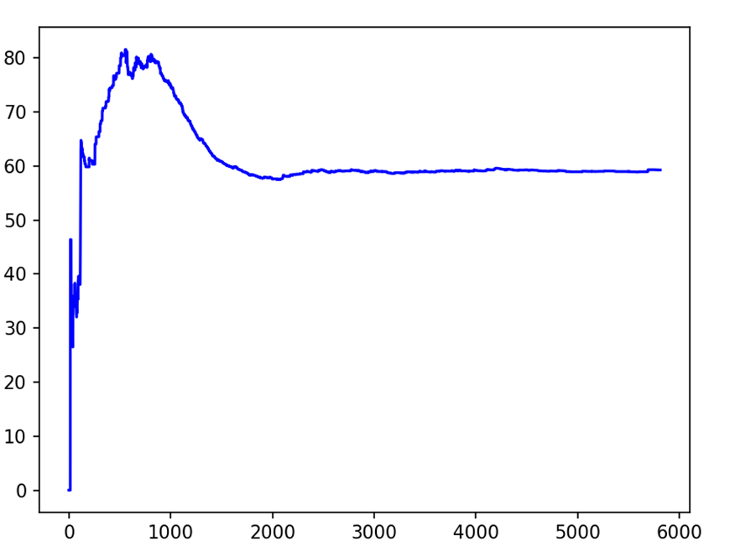

Evolution of the average time to get to the hospital

We observe a sharp increase in the average time it takes for people to reach the hospital, peaking at around the 80th cycle. This initial spike is likely due to a surge in infections early in the simulation, which causes traffic congestion and extends travel times to hospitals. Following this period, the average travel time decreases, likely due to the increased number of TPG stops and hospitals, which improves accessibility and reduces congestion.

**Conclusion**

The agent-based model offers a valuable framework for studying the complex interactions between public health and public transportation systems. By simulating disease spread dynamics and interventions, it can inform policy decisions aimed at mitigating disease transmission and enhancing public health outcomes.

**Limitations**

* The model's portrayal of environmental reactions, such as the arbitrary placement of hospitals and addition of transportation lines, may lack realism.
* Simplified disease transmission dynamics may limit the model's accuracy in representing real-world scenarios.
* Homogeneous behavior and interaction patterns among individuals may not capture the diversity of human behaviors.
* Lack of consideration for geographical and demographic variations may affect the model's generalizability.

Strengths:

* Structured data underpins the model's integrity.
* Individuals are categorized into distinct groups, enriching the simulation's complexity.
* Numerous interactions are accounted for, enriching the model's fidelity.
* Despite initial delays, the experiment ultimately yields the anticipated results.

Weaknesses:

* Lack of calibration and validation against real-world data (population density) may impact the reliability of model predictions.
* TPG stop agents do not have a defined maximum capacity, which could potentially skew simulation outcomes. During the initialization phase, some TPG stops were removed due to their excessive number.
* Limited consideration of socio-economic factors and behavioral changes during disease outbreaks may oversimplify the modeling of dynamic systems.
* The behavior of the people agents in the simulation is overly simplistic, as they are limited to only two actions. This limitation may affect the complexity and accuracy of the simulation outcomes.

**Recommendations for Model Improvement**

Future iterations of the model could benefit from incorporating:

1. **Refine Disease Dynamics:**

To enhance the realism of the model, we suggest incorporating different stages of infection and symptoms and recovery. This would allow for a more nuanced representation of disease progression and transmission dynamics. Additionally, consider adjusting transmission rates based on the health status of individuals, reflecting the varying infectiousness of individuals at different stages of the disease. Exploring hereditary factors' influence on disease spreading patterns to enhance model sophistication.

1. **Enhance Individual Behaviors:**

To better capture human behavior in response to the epidemic, it's essential to model realistic movement patterns and adherence to preventive measures. Incorporating realistic decisions especially regarding the symptoms of the agent and preventive measures such as social distancing and mask-wearing in the decision-making process made by agent can provide accurate results.

1. **Consider Agent Diversity:**

To better reflect the diversity of the population, consider simulating more age groups, socioeconomic statuses, and real health conditions among individuals. Including attributes such as vaccination status and susceptibility factors can provide a more comprehensive understanding of the impact of the epidemic on different demographic groups.